Office Phone: - 49233982
Amit G. Parikh
Mobile:-9869905779 ® 45242910
GSTIN-27ACJPP2955J1Z4

GENERAL SUPPLY CORPORATION
Shaumitra G Parikh
Mobile:- 9821361314 , 8369398586 ® 35989674
GSTIN-27AAGPP1621C1Z5

S . K U M A R & B R O S .
3rd Central Building , Grd. Flr. , 11 , Bomanji Master Road , Mumbai :- 400 002.
INSULATING -:- ELECTRICALS -:- ELECTRONIC -:- HARDWARE -:- MATERIALS
Empire , Fibreglass , Cotton , Silicon , Teflon , P.V.C. , Heatshinkable , etc. TUBE , CABLE , WIRE , CLOTH , TAPE .
Solder Items , Paste , Tester , Fuse Wire , All Cord Wires, Iron Element , T.V. & Cable Plug , Socket , Pin , & Splitter
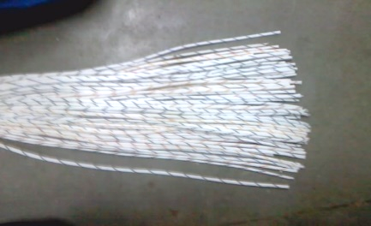  ART SILK TUBE / Sleeves | 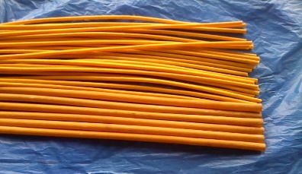  FIBREGLASS “B” CLASS YELLOW TUBE | 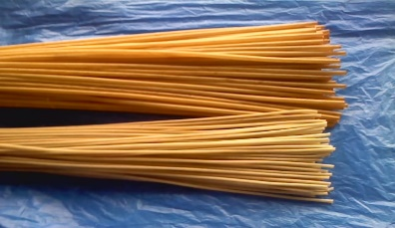  FIBREGLASS “B” CLASS WHITE SPECIAL TUBE | 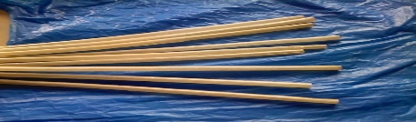  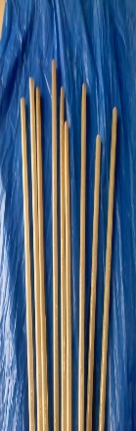  FIBREGLASS “F” CLASS TUBE |  | 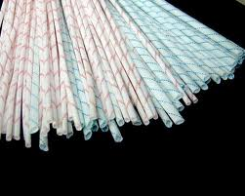  FIBREGLASS PVC COATED CHINA TUBE
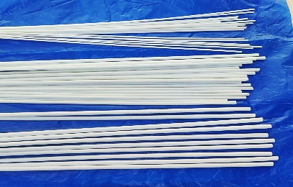  FIBREGLASS SILICON “H” CLASS CHINA TUBE | PVC CORD  BLACK , GREY Colour  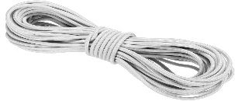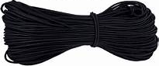 | PVC PIPES  BLACK, RED, BLUE, YELLOW , GREEN, WHITE GREY Colou  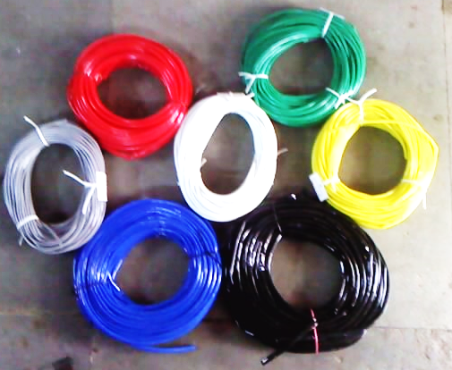  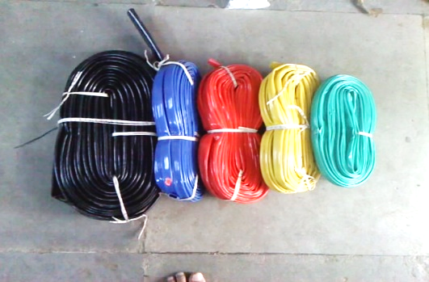 |  |  | 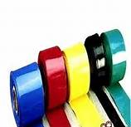  P.V.C. HEAT SHINKABLE TUBE
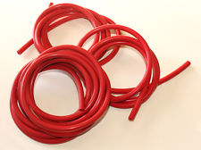  SILICON RUBBER TEFLON TUBE | 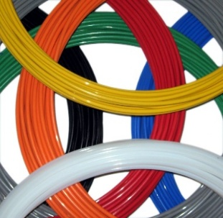  TEFLON TUBE | 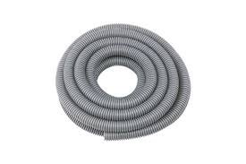  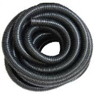  PVC Flexible Pipe | 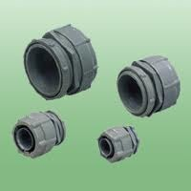  PVC Flexible Pipe Adaptor |  | 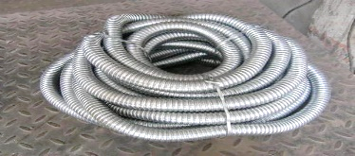  Galvanished G.I. Flexible Pipe
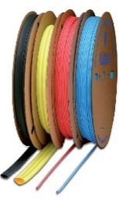  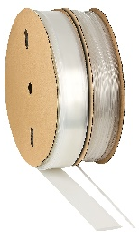  Rubber Type HeatShrinkable Tubing Available in All Colour | M a r k i n g P r i n t i n g  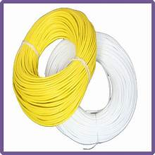  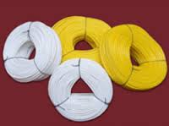  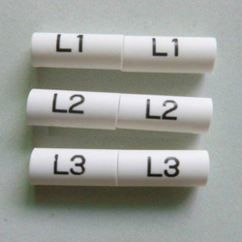  S l e v e / T u b i n g | 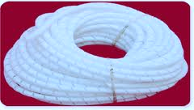  PE SPIRAL WRAPPING TUBE | 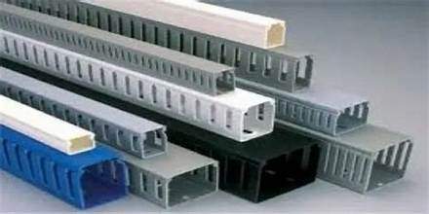  PVC Channel Box |  | 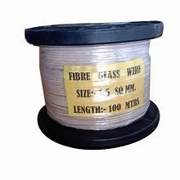  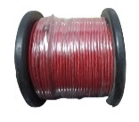  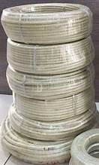  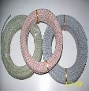  Fiber Glass Varnished Cable
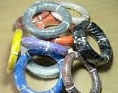  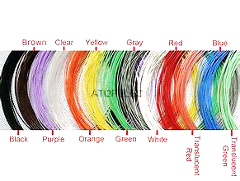  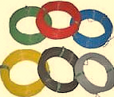  TEFLON CABLE | 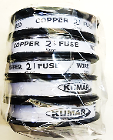  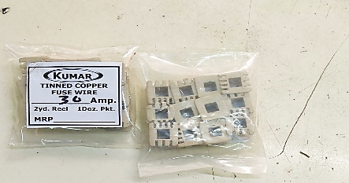  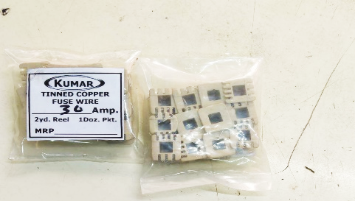  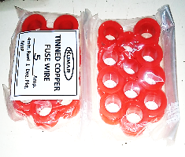  Tinned Copper Fuse Wire |   Insulating Varnish | 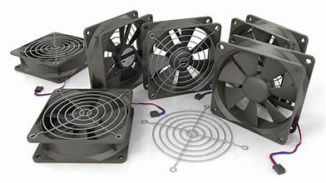  C o o l i n g F a n |  | 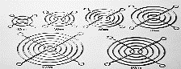  Cooler Fan Grill / Jalli
Office Phone: - 49233982
Amit G. Parikh
Mobile:-9869905779 ® 45242910
GSTIN-27ACJPP2955J1Z4

GENERAL SUPPLY CORPORATION
Shaumitra G Parikh
Mobile:- 9821361314 , 8369398586 ® 35989674
GSTIN-27AAGPP1621C1Z5

S . K U M A R & B R O S .
3rd Central Building , Grd. Flr. , 11 , Bomanji Master Road , Mumbai :- 400 002.
INSULATING -:- ELECTRICALS -:- ELECTRONIC -:- HARDWARE -:- MATERIALS
Empire , Fibreglass , Cotton , Silicon , Teflon , P.V.C. , Heatshinkable , etc. TUBE , CABLE , WIRE , CLOTH , TAPE .
Solder Items , Paste , Tester , Fuse Wire , All Cord Wires, Iron Element , T.V. & Cable Plug , Socket , Pin , & Splitter
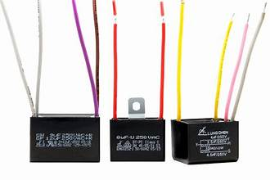  C A P A C I T O R S  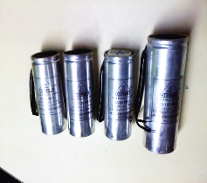  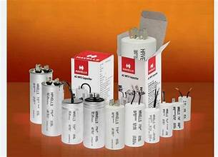  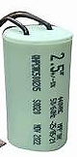  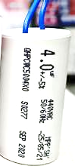  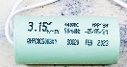  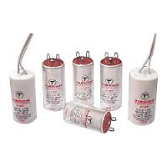 |  | 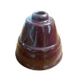    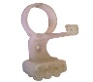  FAN CANOPY  CAPACITOR  STAND.WITH  CONNECTOR |  | 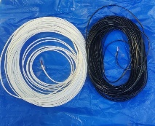  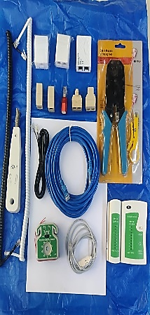  Telephone Products & Accessories
  TRFLON PLUMBER TAPE | PVC HEATSEALING  NON ADHESIVE TAPE  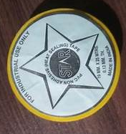 | 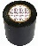  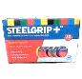  PVC ADHESIVE WONDER STEELGRIP TAPE | 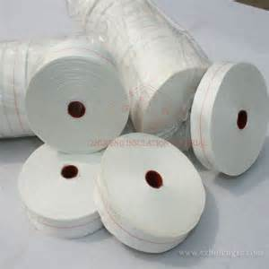  FIBREGLASS UNVARNISHED TAPE |  |  | 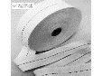  WEBBING COTTON TAPE
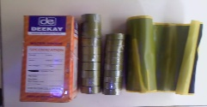  Rubber Submersible Tape | 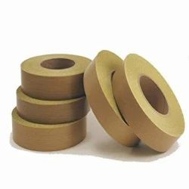  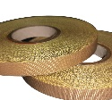  TEFLON TAPE ADHESIVE | 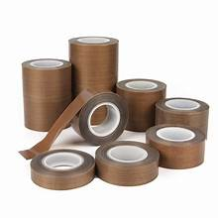  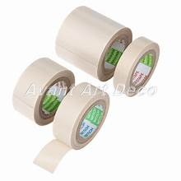  TEFLON TAPE  NON-ADHESIVE | 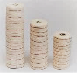  COTTON TAPE ‘LOTUS’ |  |  | 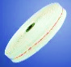  SUPERFINE COTTON TAPE
PVC SEALER AUTOMATIC MACHINE & PARTS
8”12”18”24”MACHINE & ELEMENT , RUBBER, CIRCUIT,ROTARY SWITCH & KNOB,& SPRING ,CILPS, TEFLON TAPE. BUSH,TRANSFORMER 12” WOODEN PATTI (PROCELINE, MICA, AND WITH 2PIN WIRE)
